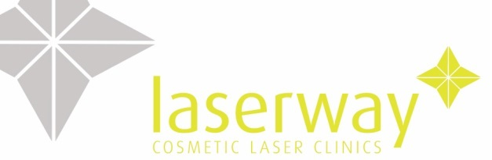

SKIN REJUVENATION

Most people would like to keep a young and fresh look forever! Unfortunately this is not easy. Skin ages due to internal and external factors such as the decreased production of collagen and excessive sun exposure.
Skin Rejuvenation treatment will help you to keep a younger and fresher looking face. Skin Rejuvenation makes your face look smoother by removing age spots, diffusing redness, improving the appearance of fine lines, enlarged pores and skin tone. Uneven pigmentation will also be reduced

How does the treatment work?
The FDA approved laser systems release precisely controlled strong pulses of filtered light that stimulate the fibroblast cells within the skin that produce collagen and elastin. This improves the radiancy and tightness of the skin, controlling enlarged pores, and giving a more uniform complexion. Diffuse redness is caused by an increased number of tiny blood vessels which contain haemoglobin. When cells containing a lot of melanin and haemoglobin are hit with the right type of light, they heat up and are destroyed, within a few thousandths of one second.

What is the procedure?
The skin is thoroughly cleansed. A cold gel is applied to the area. You will be asked to put on goggles. The light applicator is placed onto the skin and a short pulse of light is released. The applicator is then moved to the neighbouring area and the process is repeated until the entire area is treated. The chilled gel is removed and the area moisturised.
Can my skin be treated?
The ideal candidate is fair skinned. If there are any areas of broken skin, treatment is delayed until the area has completely healed.

Can symptoms of Rosacea be treated?
Rosacea is a skin aliment that leaves people red faced from dilated blood vessels and chronic flushing. Rosacea can also cause pimples and/ or blisters on the nose and cheeks. For women and men, IPL can successfully treat dilated blood vessels and redness without injuring the surrounding healthy skin, while reducing the episodes of flushing with long-term effctiveness, PLEASE NOTE LASER WILL NOT CURE ROSACEA IT WILL ONLY TREAT THE SIDE EFFECTS OF ROSACEA.
How many treatments do I need?
Treatments are carried out every four weeks. 4-6 treatments are recommended for maximum results. Therefore top-up sessions are performed as required.
How long does it take?
A facial treatment usually takes about 1 hour.
Does it hurt?
No anaesthesia is required and most clients describe the discomfort as moderate. Every client describes the sensation differently. You will feel heat on the area.
Are there any side effects?
The skin can become red after treatments. However most patients experience no side effects and any skin reaction usually disappears within a few hours.
Are there any special precautions before and after treatment?
It is EXTRMELY important to avoid sun tanning before the procedure. Otherwise the light will be absorbed by melanin in the skin surface, making the treatment more uncomfortable and less effective. An ice pack is normally applied to the area after treatment. It is recommended to use a sunscreen minimum SPF30 for a few weeks following the treatment.
What can I expect?
Redness and a slight warming sensation are normal after treatment. A cooling pack will be applied to the skin to ease these symptoms. You may see a darkening of any pigmented spots before they fall off, leading to an evening skin tone. Tightening of the skin should increase over a 24 hour period, building up with each treatment and lasting between treatments. Some patients notice a slight swelling over the cheekbones, which may last up to 72 hours.

Pigmentation can also be treated with Gentlemax pro. We will determine what laser will give you the best results.

Aftercare

- Cold compresses and the use of 100% Aloe Vera are recommended if necessary

For the next 24-48 hours avoid all heat treatments such as:

- Excessive exercise
- Avoid all perfumed creams, soaps and lotions on the treatment area.
- Do not touch pick or scratch or rub the area
- Avoid hot showers etc
- Avoid the use of AHAs including lactic & Glycolic acid and Retin A etc.

Only mineral make-up can be worn for 24 hours after treatment (please ask clinicians for advice in Laserway).

For the next 4 weeks:
- You should avoid exposure (on the treated area) to UV light i.e. sun-beds and sun bathing for at least one month before and after treatment.
- A minimum of SPF 30+ should be applied regularly. Pre and Post U.V. exposure can cause pigmentation changes to the skin.

