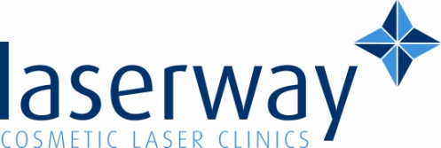 [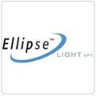](http://www.google.co.uk/imgres?q=ellipse+ipl+acne+treatment&hl=en&biw=1024&bih=652&tbm=isch&tbnid=MpKZKY4K0fP1QM:&imgrefurl=http://www.aurabolton.co.uk/5.html&docid=87AU7_L-1U3B7M&imgurl=http://www.aurabolton.co.uk/sei/s/665/141.jpg&w=150&h=150&ei=3xJCUdzuFMex0AXVsIDQAQ&zoom=1&ved=1t:3588,r:66,s:0,i:283&iact=rc&dur=499&page=4&tbnh=120&tbnw=118&start=54&ndsp=21&tx=79&ty=60)Acne treatment (IPL)

How it works?

The Intense Pulsed Light system releases yellow, green and red light that is emitted in a series of short pulses. The yellow/green light destroys the bacteria that live in the skin and cause acne, while the red light directly targets the overactive sebaceous glands that cause outbreaks of pustules. This targeted eating deep in the skin causes shrinkage of the inflamed sebaceous glands and helps to prevent over-production of excess sebum.

**Need Prep to the laser?**

This treatment can be carried out on its own or with prep to the treatment depending on the stage of acne, skin type, sensitivity, medication etc. This will be discussed at the consultation.

The prep that can be used is micro dermabrasion or peels; they can remove the thick layer of dead skin cells that prevent deeper layers of skin from receiving essential nutrients and vitamins. It is an effective way to rejuvenate your skin by regenerating skin cells.

It can be used to stimulate the dermal layer of the skin to promote deeper exfoliation, ph balancing and correction of problematic skin types.

Consultations are FREE of charge; please call to book yours for professional advice.

Best to come with no self tan on the area and 4-6 weeks after sun exposure, please note we can not treat active tan or sun bed use.

**Ballymena clinic**

**82 Lower Mill Street**

**Call: 02825 638209**



**Add us on face book for updates and offers.**